Updated 01.04.23
eQuiPT Therapy Services
Complaints & Comments Procedure
Children & Young People have information within their Children’s Adoption Therapy Leaflet about how they can complain
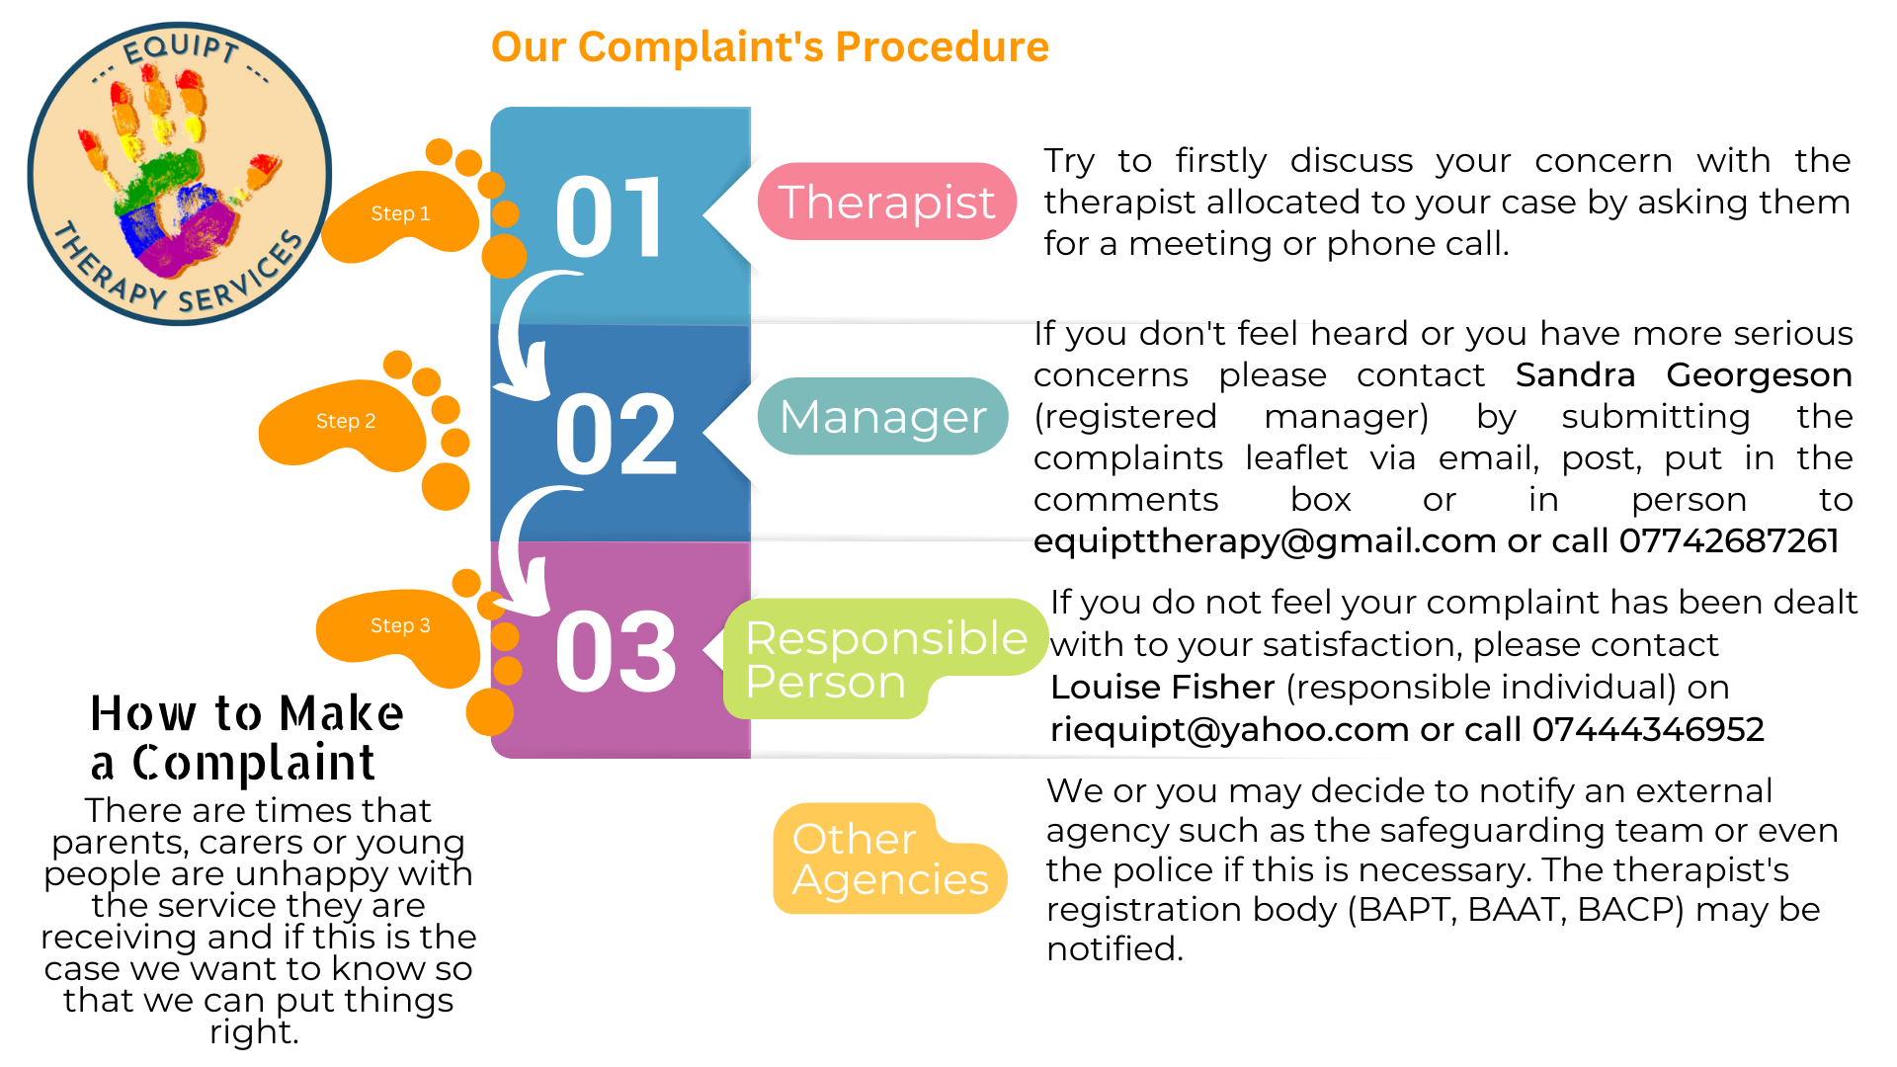
We are pleased to receive the views of everyone associated with eQuiPT Therapy Service and this includes our therapists, admin staff, parents, carers, young people and professionals. We want to make it as simple as possible for you to tell us about what you like, dislike or wish to make a formal complaint. Comments and complaints help to ensure that views, preferences, suggestions and concerns are taken into account in the development of our services and, where appropriate, are acted upon. In this respect positive comments are as valuable as negative ones.
Our Therapists
The therapists who work with eQuiPT are all freelance / independent therapists, who are paid on a sessional basis for the work that they do. They are all trained to postgraduate level and registered with a therapeutic governing body. BAPT for Play Therapists and BAAT for Art Therapists. Each therapist follows the code of ethical standards of practice dictated by their therapeutic governing body and we will follow their guidelines in the work they do for us.

If you have concerns relating to eQuiPT / or a Therapist:

- Discuss this with the person directly to see if this can be resolved. If this is not possible, please go to step 2.
- Please use the attached form to describe your complaint (emailing this to equipttherapy@gmail.com or posting it in the comments box at the unit). The registered manager will contact you regarding your complaint or if you feel it needs immediate attention you can contact the registered manager of eQuiPT in person or via phone call or email to arrange a discussion regarding your concerns.
The Registered Manager is Sandra Georgeson
Email: equipttherapy@gmail.com Telephone: 07742687261
- There may need to be an investigation of your concerns before the manager can give you a considered response. We would try to speak to the therapist that same week and come back to you with a response as soon as possible.
- If appropriate the manager will try to resolve your concern through mediation between yourself and the party concerned.
- If you do not feel that your complaint has been resolved by the manager, you can contact the Responsible Person who overseas eQuiPT LTD.
The Responsible Individual is Louise Fisher
Email: riequipt@yahoo.com Telephone: 07444346952
- After the complaint has been investigated further by the Responsible Person Louise Fisher, and if the complaint indicates possible serious malpractice, she will take the complaint to the necessary authorities to investigate. This may be the therapist’s governing body, social care or the police, if and where this is appropriate. Serious allegations will result in the therapist’s work through eQuiPT being ceased until an investigation has been completed. We would also notify Ofsted.
Comments
We love to receive your comments about our service and try to use the comments in a way to develop our service to meet the needs of our community. You can give us your comments in many different ways and if you don’t want to put your name to the comment that is fine, we will keep it anonymous. We collect your comments in a central folder on our secure One Drive and if we can action anything straight away, we will.
Throughout your child's/your intervention you can talk to the therapist or Sandra at the unit. If you feel more comfortable talking to our Admin Kerry that is fine too. You can give us your comments verbally (we will check you are happy that we write them down). During the therapy we have reviews so you can pass on any comments there or at the end meeting too. You will also be provided with an Evaluation form on which you can let us know your comments. Lastly you can use our Post box in the waiting area. Please do give us your feedback we try where possible to act on things quickly and will give you an update if you want that. We also share your comments on our website and social media so we can spread the word about our service.
If you require a formal response, your comments should be made in writing to Sandra who will acknowledge receipt as soon as possible (usually within 7 working days) and respond to your comments within 28 working days. If a response cannot be made within this period, they will inform you of the reason for the delay and provide you with a full response as soon as possible thereafter.
Complaints
If you have a complaint about our service, we really do want to hear from you, we want to make our service the very best it can be so your comments can help us do this. We would rather you tell us than not.
We take all complaints seriously and will treat you with respect and consideration through the whole of the process.
The following outlines the procedures we will follow if a complaint us made.
We will: -
- Listen carefully to all concerns
- Deal with all complaints promptly, politely and, where appropriate, confidentially
- Respond in the most appropriate way to resolve the cause of the complaint
- Learn from complaints and use them to improve the quality of our service
- If you are unhappy about any aspect of your counselling or therapy, we encourage you to discuss this directly with your therapist in the first instance. Our therapists are trained and supported to work in a person-centred way, including responding appropriately to the needs, wishes and concerns of our clients.
- If you do not feel able to address your concerns with your therapist, or wish to complain about any other aspect of eQuiPT’s service provision or organisation, you may wish to deal with this informally by discussing your concerns with the registered manager
- If you are dissatisfied with the response or if your complaint is of a serious nature which requires a formal response, you should use the following procedure to register a formal complaint. The manger will, on request, supply you with a copy of the relevant procedure.
Formal complaints
All formal complaints should be made in writing, using the attached form (by post or email) and addressed to the manger Sandra Georgeson. When making a formal complaint, it is your responsibility to:
- Bring your complaint promptly to the attention of the manger;
- Include as much detail as possible to enable us to fully understand the nature and extent of your complaint, using the attached form;
- Include any action which has already been taken, and an explanation of what you require in order to resolve the issue;
- Allow eQuiPT Therapeutic Service a reasonable time in which to deal with the complaint.
It is our responsibility to:
- Provide a written acknowledgement of receipt of the complaint within seven days;
- Make appropriately thorough and fair investigations of the complaint;
- Make recommendations and take action where appropriate;
- Inform the complainant of the response to the complaint within 28 days.
All Associate Therapists are members of an appropriate professional body, with its own code of conduct and ethical practice guidelines. Details of these can be provided on request. Any serious concerns about the conduct of a therapist can be passed to the appropriate professional body, with the consent of the complainant or you can make this complaint to the professional body yourself.
All information will remain confidential, however, in exceptional circumstances, the circumstances giving rise to the complaint may be such that it may not be possible to maintain complete confidentiality. In this case, if at all possible, the situation will be explained to the complainant before confidentiality is breached.
Updated September 2022

Adult Complaints Form / Leaflet
We work really hard to make sure that everyone we work with are happy with our service but sometimes things go wrong or there maybe something you wish to tell us that you are not happy with. We want to learn when things go wrong so it is important that you tell us so we can resolve it.

If you would like to tell us about something about eQuiPT that you are unhappy with or would like us to change, we want to hear what you have to say. You can tell us in a few different ways:-
- On our website you can send us a message https://www.equipttherapy.com/contact
- You can complete this form and post it in Comment Box in our waiting area or hand it to one of the staff.
- You can write to us at 12 Churchfield Court, Barnsley S702JT
- You can speak to one of us (We will write down your complaint) either in person or by telephone
- You can email us equipttherapy@gmail.com
- If you need someone to help you complete the form please ask a member of staff.

Please tell us more…if you need more space please continue on a separate on a separate sheet.

Tell us what you are unhappy with

How would you like this to be improved?

You can tell us your name or you don’t have to

Date…………………………………………………

For more information about our Complaints procedure please see our, “Complaints & Comments Procedure.

Children / Young Person’s Complaints Form / Leaflet

We work really hard to make sure that everyone we work with are happy with our service but there maybe something you wish to tell us that you are not happy with.

If you would like to tell us about something about eQuiPT that you are unhappy with or would like us to change, we want to hear what you have to say. You can tell us in a few different ways:-
- On our website you can send us a message https://www.equipttherapy.com/contact
- You can complete this form and post it in Comment Box in our waiting area
- You can speak to one of us (we will write down your complaint)

Please tell us more…

Tell us what you are unhappy with

How would you like this to be improved?

You can tell us your name or you don’t have to
Date………………………………

