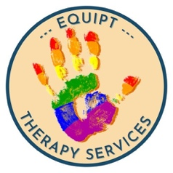
Last Updated 01.04.23
Safeguarding Children Policy

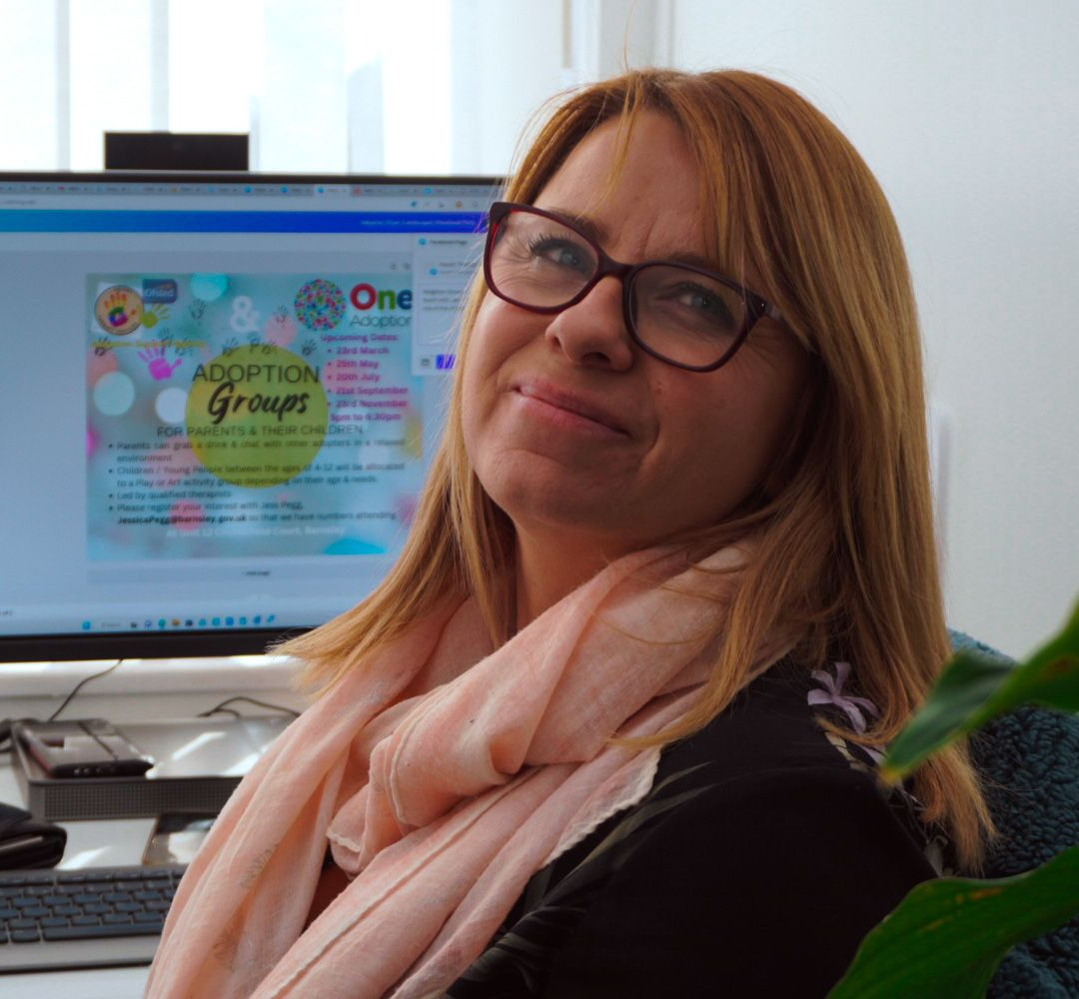

  - Our Safeguarding Lead is Sandra Georgeson (registered manager)
  - 07742687261 equipttherapy@gmail.com

Please alert our safeguard lead to any concerns you may have.

Child Protection Definition
‘Child Protection’ means protecting a child from child abuse or neglect. Abuse or neglect need not have taken place, it is sufficient for a risk assessment to have identified a ‘likelihood or risk’ of significant harm from abuse or neglect. Child Protection is the responsibility of all who work with children and families, regardless of whether this work brings them into direct work with children.
----------------------------------------------------------------------------------------------------------------
We have based out Policy and procedures on the following documentation.

- In England, the Department for Education (DfE) provides the key statutory guidance for anyone working with children and young people: Working together to safeguard children (PDF) (DfE), 2018). This sets out how organisations should work together to keep children safe. Sections 57 – 62 set out the requirements for voluntary, charity, social enterprise, faith-based organisations and private sectors.
- The DfE’s guidance What to do if you’re worried a child is being abused (PDF) describes the actions to take if you think a child is being abused or neglected.
- The DfE has published a voluntary code of practice for out-of-school settings. It includes advice on safeguarding and child protection, staff suitability, and governance (DfE, 2020).

All of our therapists involved in offering direct support to children and their legal guardians / parents or carers, may have contact with children at risk of harm in the course of their duties.
Administrative workers, volunteers, trainee or qualified play and art therapists and counsellors and support workers may also become aware of situations where a child may be at risk of being harmed, or is being harmed.

  - Specific Information for Families:
- All our Therapeutic staff have full enhanced DBS checks that are either renewed every 3 years or on the DBS Update Service (This is the method we recommend to therapists).
- Admin staff have a basic DBS Check that is renewed every 3 years or sooner.
- We do record any cause for concern in the child’s casefile and concerns are collated in our safeguarding file
- We will also complete a body map (a visual outline of a body is drawn on to indicate any physical injuries that may have occurred or been noted by the therapist)
- We will pass on our concerns to the safeguarding team or other agencies where this is appropriate
- Where we feel it is safe to do so, we will discuss the child protection issue with you as the parent first

  - Specific Information for Therapists & other Staff:

It is important that all paid or unpaid workers are alert to signs of either physical harm, neglect or emotional abuse and take appropriate action to safeguard children who may be at risk of exposure to harm.
The following outlines in detail what steps must be taken to safeguard children at risk where any form of abuse may be suspected. It outlines our commitment and obligation to equip our therapists / workers with the skills & knowledge to be able to deliver the child safeguarding policy safely.

- Therapists must make all families aware of our safe-guarding policy at the initial meeting prior to therapy starting.

Key Principles - All workers must:
• Be alert to and act on indications that a child may be being harmed or be at risk of harm;
• Be clear about their responsibilities in safeguarding the protection of children at risk;
• Act in accordance with agency Child Protection Policy procedures and guidance on children in need of support and protection.
• Never act alone, except in an emergency.

Action to take if a therapist suspects that a child may be at risk:
  - ALWAYS and IMMEDIATELY discuss any suspicions or concerns with the named Safeguarding Lead which is Sandra Georgeson and their clinical supervisor.
  - Complete the Concern Form with detailed information to be able to share essential information with relevant authorities
  - Contact the Childs Social Worker in the first instance. IF he/she are not available then ca the relevant Safeguarding Duty & Assessment Team or Police if it is an immediate danger
  - If safe to do so contact the family to let them know what you are doing, however not if you think this could place the child at harm
Investigating a concern
  - In exceptional circumstances when the Safeguarding Lead cannot be contacted and a child is in danger, a concerned Worker should bring the matter to the attention of their Local Social Work Safeguarding Services, keep detailed records of contacts and inform the Safeguarding Lead as soon as possible.
  - Regional Social Work Department and / or Police as the statutory services, will follow-up and may further investigate any child safety concerns. They will keep the Safeguarding Lead informed
  - All parties should be treated with sensitivity and respect.
  - The Safeguarding Lead in cooperation with the Worker may keep the child and legal guardians / parents / adult carers informed of their actions, unless such information is likely to put the child in danger, in which case they will inform the regional statutory services relevant to the child safeguarding case being investigated.
Emergency Contacts
If you think the child is in immediate danger, call the police on 999

Barnsley

Local Daytime Police - (0114) 2202020.
If the child's not in immediate danger, but you're still concerned about them, call our social care assessment service on (01226) 772423 (weekdays before 5pm).
Call our emergency duty team on (01226) 787789 if you’re calling after 5pm, at weekends or on bank holidays.
Rotherham
Local Daytime Police - 101
If you are calling in a professional capacity, please call the Multi Agency Safeguarding Hub (MASH) 01709 336080. We really want to understand your worries.
Select option 1 - if the family have an allocated social worker or early help worker
Select option 2 - if you require help and support and have the consent of the parent/carer to discuss your concerns with MASH/early help
Select option 3 - if you are worried a child is suffering significant harm

If you are calling outside of office hours, and it is an emergency requiring an urgent response, your call will be directed to a social worker who will be able to assist. If your concerns do not require an urgent response, please call the mash the next working day.

For situations where work patterns do not allow, such as night and weekend shifts, complete the request for help and support online. Please note the form is only to be used for this purpose.

Doncaster
Local Daytime Police – 101. or 01302 385078

If you are worried about a child and wish to speak to a person you can contact us by calling 01302 737777
or in the evening or at weekends call 01302 796000.

Sheffield

Sheffield Safeguarding Hub on 0114 273 If the child/family already has an allocated social worker please contact the Social Worker in the North, East or West area social care team.

Contact Social Care (North)
0114 203 9591

Contact Social Care (East)
0114 203 7463

Contact Social Care (West)
0114 273 4491

Procedures
What to do if you have concerns about a child
You may have concerns about a child because of something you have seen or heard, or a child may choose to disclose something to you. If a child discloses information to you, you should:
- Do not promise confidentiality, you have a duty to share this information and refer to Children’s Social Care Services.
- Listen to what is being said, without displaying shock or disbelief.
- Accept what is said.
- Reassure the child, but only as far as is honest, don’t make promises you may not be able to keep eg: ‘Everything will be alright now’, ‘You’ll never have to see that person again’.
- Do reassure and alleviate guilt, if the child refers to it. For example, you could say, ‘You’re not to blame’.
- Do not interrogate the child; it is not your responsibility to investigate.
- Do not ask leading questions (eg: Did he touch your private parts?), ask open questions such as ‘Anything else to tell me?’
- Do not ask the child to repeat the information for another member of staff.
- Explain what you have to do next and who you have to talk to. Let the child know you will be telling the designated person about your concerns.
- Take notes if possible or write up your conversation as soon as possible afterwards.
- Record the date, time, place any non-verbal behaviour and the words used by the child (do not paraphrase).
- Record statements and observable things rather than interpretations or assumptions.
- If working in a school discuss with the safe guarding officer in the school. If working with a child who has a social worker pass the information onto the social worker.
- If none of those apply notify the local safeguarding department.
- If safe to do so inform the family, if unsure discuss first with your clinical supervisor.
- Log your actions on the eQuiPT’s safeguarding log.
- If you feel your concerns are not being taken seriously go direct to the local safeguarding team.
- Each individual therapist has a duty to ensure their safeguarding training is up to date.
- EQuiPT will provide the contact details of local authority safeguarding teams.
What information will you need when making a referral to the safe guarding Team?
You will be asked to provide as much information as possible. Such as the child’s full name, date of birth, address, school, GP, languages spoken, any disabilities the child may have, details of the parents. Do not be concerned if you do not have all these details, you should still make the call.
You should follow up the verbal referral in writing, within 48hrs

Safeguarding is everyone’s responsibility:
Child protection is a part of safeguarding and promoting welfare. This refers to the activity which is undertaken to protect specific children who are suffering or are at risk of suffering significant harm. As adults and/or professionals or volunteers, everyone has a responsibility to safeguard children and promote their welfare.
Safeguarding and promoting the welfare of children – and in particular protecting them from significant harm - depends upon effective joint working between agencies and professionals that have different roles and expertise and we at equipt recognise our part in this.
Individual children, especially some of the most vulnerable children and those at greatest risk of social exclusion, will need co-ordinated help from health, education, children’s social care, and quite possibly the voluntary sector and other agencies, including youth justice services.
For those children who are suffering, or at risk of suffering significant harm, joint working is essential, to safeguard and promote welfare of the child(ren) and – where necessary – to help bring to justice the perpetrators of crimes against children. All agencies and professionals should:
- be alert to potential indicators of abuse or neglect;
- be alert to the risks which individual abusers, or potential abusers, may pose to children.
- share and help to analyse information so that an assessment can be made of the child’s needs and circumstances;
- contribute to whatever actions are needed to safeguard and promote the child’s welfare;
- take part in regularly reviewing the outcomes for the child against specific plans; and
- work co-operatively with parents unless this is inconsistent with ensuring the child’s safety.
Definitions of abuse and neglect:
Abuse and neglect are forms of maltreatment of a child. Somebody may abuse or neglect a child by inflicting harm, or by failing to act to prevent harm. Children may be abused in a family or in an institutional or community setting; by those known to them or, more rarely, by a stranger. They may be abused by an adult or adults or another child or children.
Physical abuse
Physical abuse may involve hitting, shaking, throwing, poisoning, burning or scalding, drowning, suffocating, or otherwise causing physical harm to a child. Physical harm may also be caused when a parent or carer fabricates the symptoms of, or deliberately induces illness in a child.
Emotional Abuse
Emotional abuse is the persistent emotional maltreatment of a child such as to cause severe and persistent adverse effects on the child’s emotional development. It may involve conveying to children that they are worthless or unloved, inadequate, or valued only insofar as they meet the needs of another person. It may feature age or developmentally inappropriate expectations being imposed on children. These may include interactions that are beyond the child’s developmental capability, as well as overprotection and limitation of exploration and learning, or preventing the child participating in normal social interaction. It may involve seeing or hearing the ill-treatment of another. It may involve serious bullying causing children frequently to feel frightened or in danger, or the exploitation or corruption of children. Some level of emotional abuse is involved in all types of maltreatment of a child, though it may occur alone.
Sexual Abuse
Sexual abuse involves forcing or enticing a child or young person to take part in sexual activities, including prostitution, whether or not the child is aware of what is happening. The activities may involve physical contact, including penetrative (eg: rape, buggery or oral sex) or non-penetrative acts.
They may include non-contact activities, such as involving children in looking at, or in the production of, pornographic material or watching sexual activities, or encouraging children to behave in sexually inappropriate ways.
Neglect
Neglect is the persistent failure to meet a child’s basic physical and/or psychological needs, likely to result in the serious impairment of the child’s health or development. Neglect may occur during pregnancy as a result of maternal substance abuse. Once a child is born, neglect may involve a parent or carer failing to provide adequate food and clothing, shelter including exclusion from home or abandonment, failing to protect a child from physical and emotional harm or danger, failure to ensure adequate supervision including the use of inadequate care-takers, or the failure to ensure access to appropriate medical care or treatment. It may also include neglect of, or unresponsiveness to, a child’s basic emotional needs.
Staff awareness
All staff will be made aware of this policy as part of their initial induction process and there will be regular briefings and updates for all staff.
The Director Sandra Georgeson with Louise Fisher as Responsible Individual are Designated Safeguarding Leads and have completed the necessary training which will be updated annually.
Reviewing the Policy and Procedure
This policy and procedure will be reviewed every year, this will include checking telephone numbers, accuracy of personnel details, and any updates required by a change in local or national policy.

